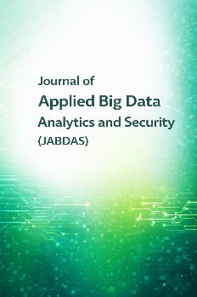


Journal of Applied Big Data Analytics
and Security

Title of the Manuscript (16-point font size, bold, left-aligned, Times New Roman)

Author Full Name ¹, Author Full Name ², …

¹Department name, Name of University, City, Postal code, Country (Font size 10, Times New Roman, italic)
²Department name, Name of University, City, Postal code, Country (Font size 10, Times New Roman, italic)

A R T I C L E
I N F ORMATION

Article History
Received:
Revised:
Accepted:
Published:

Vol. 2027, No. 1

DOI:

A B S T R A C T

- The font type is Times New Roman.
- The font size is 10 pt.

Keywords: Keyword 1; Keyword 2; Keyword 3; Keyword 4; Keyword 5.

- Introduction (Heading 1: font size 11, Times New Roman)
- The font name is Times New Roman.
- The font size is 10 pt.

- Literature Review (Heading 2: font size 11, Times New Roman)

Big Data Architecture (Font size 11, Times New Roman, italic)
- The font name is Times New Roman.
- The font size is 10 pt.

- All figures must be numbered consecutively.
- Figure captions must be formatted in bold.

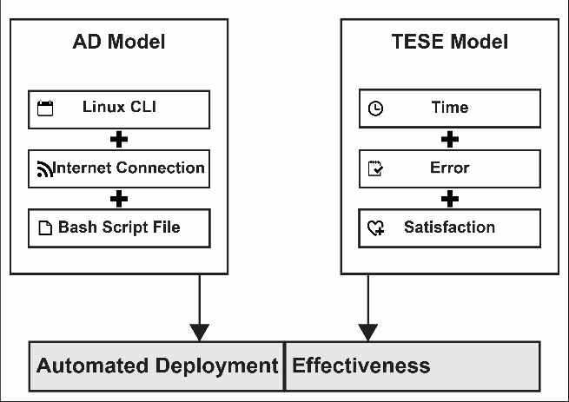
Figure 1. Automated Deployment Effectiveness proposed model.

(A) Workflow layer

Moreover, the studies referenced [15], [16] highlight related efforts. A study [17] showed that automated Bash scripts executed error-free with low resource consumption, enhancing cybersecurity by reducing attack surfaces.

(B) Formula layer
$$AD=LC+IC+BSF$$ | (1)
Where:
- LC = Linux CLI
- IC= Internet Connection
- BSF= Bash Script File

AD Model

(A) Python

Although generally easy to install, Python may encounter corrupted downloads, missing dependencies, or misconfigured environment variables [31]-[33].

(B) Robotic Process Automation

The Robotic Process Automation (RPA) maintained a 0% error rate, representing a 100% error rate reduction compared to the 12% error in the manual process [19].

3. Research Methodology

To address these gaps, this study introduces a framework, a model for evaluating Big Data tool usability across interfaces. It focuses on five dimensions and compares command-line environments with single-platform like Jupyter Notebook.

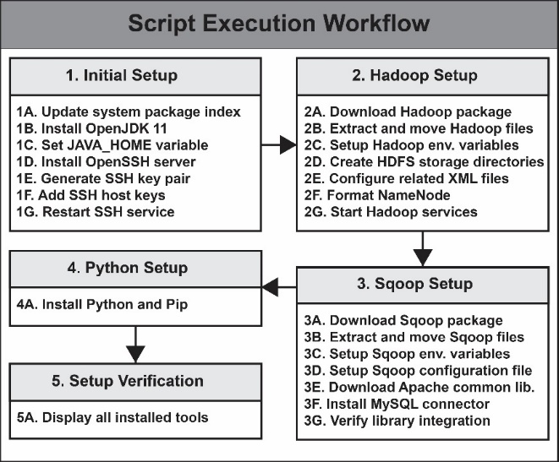

Figure 2. Script execution workflow.

4. Results and Discussion

After data was collected from IT practitioners, they were entered and analyzed using the SPSS application.

4.1 Findings of Layer

After data was collected from IT practitioners, they were entered and analyzed using the SPSS application.
- All tables must be numbered consecutively.
- Table must be Bold.

Table 1. Attacks Layer

Header1 | Header 2 | Header 3
Main group | Group 1[1],[2] | Apple
Main group | Group 2 [8] | Banana
Main group | Group 3 [99] | Coconut

5. Conclusion

- The font name is Times New Roman.
- The font size is 10 pt.

Conflicts Of Interest
The author declares no conflicts of interest.

Funding
No funding.

Acknowledgment
This work was supported by supporter A.

Appendix
Appendixes, if needed, appear before the acknowledgment.

References (APA format) and should be cited as numbers [1] in the main text

- A. K. Sandhu, “Big data with cloud computing: Discussions and challenges,” Big Data Min. Anal., vol. 5, no. 1, p. 32-50, Mar. 2022, doi: 10.26599/BDMA.2021.9020016.
- M. Xu, D. Fralick, J. Z. Zheng, B. Wang, X. M. Tu, and C. Feng, “The differences and similarities between two-sample t-test and paired t-test,” Shanghai Arch. Psychiatry, vol. 29, no. 3, pp. 185–186, Jun. 2017, doi: 10.11919/j.issn.1002-0829.217070.
- DataScienceSource, Bash Script for Automated Big Data Tool Installation, 2025. Available: https://github.com/datasciencesource/bash_script. Accessed: Feb. 14, 2025. DataScienceSource, Bash Script for Automated Big Data Tool Installation, 2025. Available: https://github.com/datasciencesource/bash_script. Accessed: Feb. 14, 2025.
- T. H. Davenport and D. Patil, “Is data scientist still the sexiest job of the 21st century?,” Harvard Business Review, Jul. 2022. Available: https://www.tomdavenport.com/is-data-scientist-still-the-sexiest-job-of-the-21st-century. Accessed: Feb. 14, 2025.

Biographies of Authors
 | Author A. A brief biography of the author (4–6 lines), including academic background, current affiliation, and research interests. The email address and ORCID iD should be provided at the end of the biography.  Email: mail@email.com  ORCID iD: 0000-0000-0000-0000
Mony Ho is a Ph.D. candidate in Information Technology at Lincoln University College, Malaysia, and holds a Master’s degree in IT and Data Science from the European International University, France, and Master Trainer from the Republic of Korea. He serves as a master trainer at the Ministry of Labor and Vocational Training and lectures part-time at several universities in Cambodia. His teaching and research interests include data science and cybersecurity.
Email: mail@email.com
ORCID iD: 0000-0000-0000-0000

